**Question/Answer Booklet**

**Name:**

**PHYSICAL EDUCATION STUDIES YEAR 11 ATAR**

**Semester 1 Exam 2019**

**Time allowed for this paper**

Reading time before commencing work: 0 minutes

Working time for paper: 2 Hours

***To be provided by the candidate***

Standard items: pens, pencils, eraser, correction fluid, ruler, highlighter

**Important note to candidates**

No other items may be taken into the examination room. It is **your** responsibility to ensure that you do not have any unauthorised notes or other items of a non-personal nature in the examination room. If you have any unauthorised material with you, hand it to the supervisor **before** reading any further.

**Structure of paper:**

|  |  |  |  |
| --- | --- | --- | --- |
| Section | Number of questions available | Number of questions to be attempted | Marks available |
| **Section One:**  Multiple-Choice | 20 | 20 | 20 |
| **Section Two:**  Short Answer | 14 | 14 | 65 |
| **Section Three:**  Extended Answer | 3 | 2 | 20 |
|  |  |  | **105** |

Answer the twenty **(20)** Multiple-Choice questions on the separate Multiple-Choice answer sheet provided.

**Multiple Choice (20 marks)**

1. Which of the following is not a characteristic of capillaries?

(a) Exchange carbon dioxide and oxygen.

(b) Have thin walls.

(c) Are microscopic.

(d) Have strong elastic walls.

2. The insertion point for the triceps muscle group is located on the:

(a) Ulna.

(b) Radius.

(c) Humerus.

(d) Scapula.

3. Extension of the knee joint involves:

(a) The hamstrings and gastrocnemius coming closer together.

(b) The hamstrings and gastrocnemius moving further apart.

(c) The tibialis anterior and gastrocnemius coming closer together.

(d) The tibialis anterior and gastrocnemius moving further apart.

4. Which of the following muscle groups are antagonistic pairs?

(a) Hamstrings, soleus.

(b) Pectorals, latissimus dorsi.

(c) Trapezius, biceps.

(d) Tibialis posterior, soleus.

5. Identify the joint movement performed by a swimmer’s shoulders during a backstroke race:

(a) Adduction.

(b) Flexion.

(c) Extension.

(d) Circumduction.

6. Which of the following statements about balance is TRUE?

(a) A lower centre of gravity and lower centre of mass decreases balance.

(b) A higher centre of gravity and higher centre of mass increases balance.

(c) A lower centre of mass and lower centre of gravity increases balance.

(d) A higher centre of mass and lower centre of gravity increases balance.

The picture below refers to Question **7 and 8.**

7. In order to achieve maximum acceleration, the athlete above needs to apply large amounts of force with each stride. This is an example of:

(a) Newton’s First Law of Motion.

(b) Newton’s Second Law of Motion.

(c) Newton’s Third Law of Motion.

(d) Newton’s Fourth Law of Motion.

8. Between the 30-40m mark of the race the athlete’s acceleration measures zero. This means he has:

(a) Decreased his speed.

(b) Increased his speed.

(c) Maintained his speed.

(d) Stopped running.

9. Sam’s swim coach calculates the average number of freestyle strokes she performs in a minute. This is a measure of Sam’s:

(a) Angular velocity.

(b) Angular acceleration.

(c) Angular speed.

(d) Angular distance.

10. By bending her knees on landing, Jane increases:

(a) Velocity.

(b) Inertia.

(c) Momentum.

(d) Impulse.

11. Long jump can be classified as a:

(a) Discrete skill.

(b) Continuous skill.

(c) Serial skill.

(d) Fine motor skill.

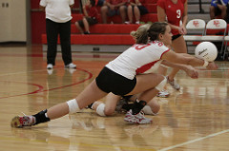12. In receiving a serve over the net, Phillipa decides to dig and moves accordingly. With reference to the Information Processing Model, this action is known as:

(a) Input.

(b) Output.

(c) Stimulus.

(d) Decision making.

13. Which of the following skills can be classified as the most discrete skill?

(a) 110m hurdles.

(b) Swimming 100m.

(c) Basketball free throw.

(d) Basketball lay-up.

14. Knowledge of results is an example of:

(a) Inherent feedback.

(b) Concurrent feedback.

(c) Extrinsic feedback.

(d) Intrinsic feedback.

15. During the second phase of learning, athletes should be encouraged to:

(a) Use their own feedback to detect and correct errors.

(b) Keep the learning environment exactly the same.

(c) Increase their reliance on augmented feedback to perfect the skill.

(d) Develop an understanding of how to perform the skill.

16. Which of the following is the best example of terminal feedback during a 100m swim race?

1. Hearing the crowd cheer when you lift your head to breathe.
2. Seeing the other swimmers next to you at the end of the first lap.
3. Feeling the movement of your arms with each stroke.
4. Seeing your time and final placing on the scoreboard.

17. Which of the following muscle groups are **not** antagonistic pairs?

1. Biceps, triceps.
2. Trapezius, deltoids.
3. Tibialis anterior, gastrocnemius.
4. Gastrocnemius, soleus.

18. To produce the movement in the picture below, the ballerina has performed:

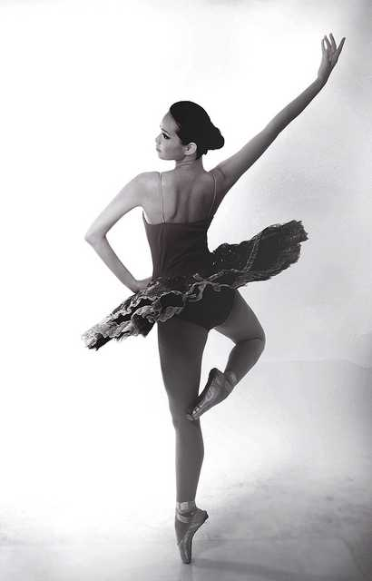

1. Plantar flexion of the ankle.
2. Dorsi flexion of the ankle.
3. Supination of the ankle.
4. Rotation of the ankle.

19. Which of the following muscles does not have its insertion point located on the humerus?

1. Deltoid.
2. Latissimus dorsi.
3. Biceps.
4. Pectoralis major.

20. Intrinsic feedback can also be known as:

1. Augmented feedback.
2. Extrinsic feedback.
3. Concurrent feedback.
4. Inherent feedback.

**Short Answer (60 marks)**

This section has **fourteen (14)** questions. Answer **all** questions. Write your answers in the spaces provided in this Question/Answer Booklet. Wherever possible, confine your answers to the line spaces provided. Use a blue or black pen (**not** pencil) for this section.

**Question 21 (3 marks)**

Identify the bones A through to C on the diagram below.

**C**

**B**

**A**

|  |  |  |
| --- | --- | --- |
| **A.** | **B.** | **C.** |

**Question 22 (4 marks)**

The body consists of three types of blood vessels: arteries, veins and capillaries. Compare and contrast **two (2)** characteristics of veins and arteries.

**Question 23 (4 marks)**

**A B**

In reference to the picture above, identify:

|  |  |
| --- | --- |
| 1. Joint movement (from A to B) |  |
| 1. Agonist muscle |  |
| 1. Origin (of agonist) |  |
| 1. Insertion (of agonist) |  |

**Question 24 (5 marks)**

Slow-twitch muscle fibres are also known as Type I muscle fibres. Briefly describe **three (3)** characteristics of slow-twitch fibres other than colour that differ from fast-twitch muscle fibres. Identify one activity suited to slow-twitch muscle fibres providing a reason for your answer.

**Question 25 (6 marks)**

Identify the **muscles** A through to F on the diagram below.

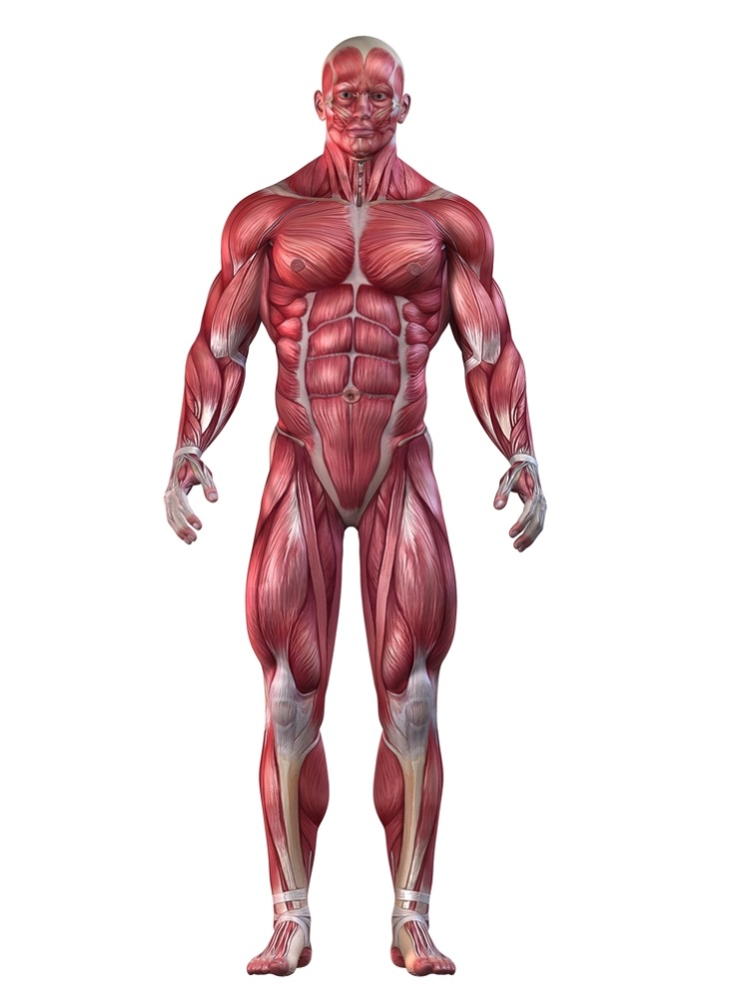

**A**

**B**

**C**

**D**

**E**

**F**

|  |  |  |
| --- | --- | --- |
| **A.** | **B.** | **C.** |
| **D.** | **E.** | **F.** |

**Question 26 (7 marks)**

Motor skills can be classified according to a number of different factors, including the amount of muscle involvement and the effects of the environment.

(a) Explain the difference between gross and fine motor skills and provide a volleyball example of each. (3 marks)

(b)(4 marks)

Place the following activities (A, B, C, D) on the continuum below.

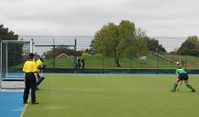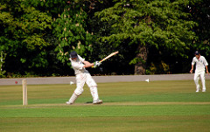

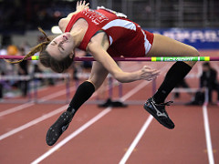

1. Cricket stroke **B**. Penalty stroke (green shirt)

**C**. High jump **D**. Surfing

**OPEN CLOSED**

**Question 27 (4 marks)**

The image below shows a hockey goal keeper defending a penalty corner. The attacking team passes the ball to the top of the circle, where a forward will hit or flick the ball towards the goal. The success of the goal keeper will depend on how efficiently he can progress through the four phases of information processing.

Complete the diagram below by identifying the name of phases 2 and 3 and describing exactly what the goal keeper would need to do in both of these phases.

Phase 1 – Input

Explanation

Goal keeper uses senses of sight and sound to identify the cues in the environment

Phase 2 ________________

Explanation

Phase 4 – Feedback

Explanation

Goal keeper receives information about his performance (ie ball goes in goal or is saved)

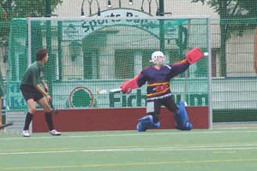

Phase 3 ___________________

Explanation

**Question 28 (4 marks)**

Explain **two (2)** differences in skill learning among children and their implication for coaching.

**Question 29 (4 marks)**

Feedback can be provided in various forms. Briefly explain **two (2)** purposes of providing feedback to athletes.

**Question 30 (3 marks)**

Define the terms positive, negative and zero acceleration and provide an example of each during a 200-metre freestyle swim.

**Question 31 (8 marks)**

1. Other than gravity, there are several factors that will impact the path of projectiles. Define and apply **three (3)** factors that will affect the path of a shot put. (6 marks)

1. To achieve maximum horizontal distance, a projectile should be released at a 45⁰ angle. Other than shot put, explain one sporting example where it is necessary to have an angle greater than 45⁰, and one example where it is necessary to have an angle less than 45⁰.

(2 marks)

**Question 32 (3 marks)**

When teeing off, a golfer must maximise the speed of the club to achieve maximum velocity onto the ball. Identify and explain the coordination of movement the golfer would utilise to achieve maximum club speed.

**Question 33 (6 marks)**

Using specific examples, identify **three (3)** types of motion in the picture below.

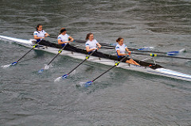

**Question 34 (4 marks)**

Using examples, explain **two (2)** types of balance a gymnast may display during a floor routine.

**Extended Answer (20 marks)**

This section contains three (3) questions. **You must answer two (2) of these questions.** Write your answer in the spaces provided.

Spare pages are included at the end of this booklet. They can be used for planning your responses and/or additional space if required to continue an answer.

* Planning: if you use the spare pages for planning, indicate this clearly at the top of the page.
* Continuing an answer: If you need to use the space to continue an answer, indicate in the original space where the answer is continued, i.e. give the page number. Fill in the number of the question that you are continuing to answer at the top of the page.

**Question 35 (10 marks)**

The three golfers pictured below are in different phases of their golf career. The child pictured on the left is attempting to hit a golf ball for the first time, the recreational golfer pictured in the middle is working to improve his game, while the adult pictured to the right is playing in a professional tournament.

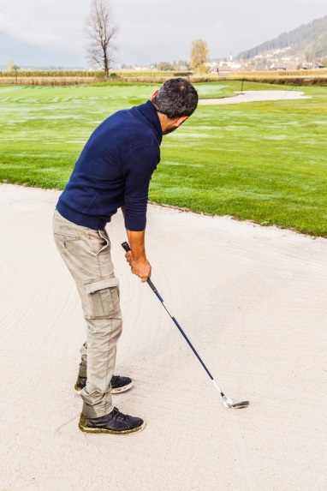

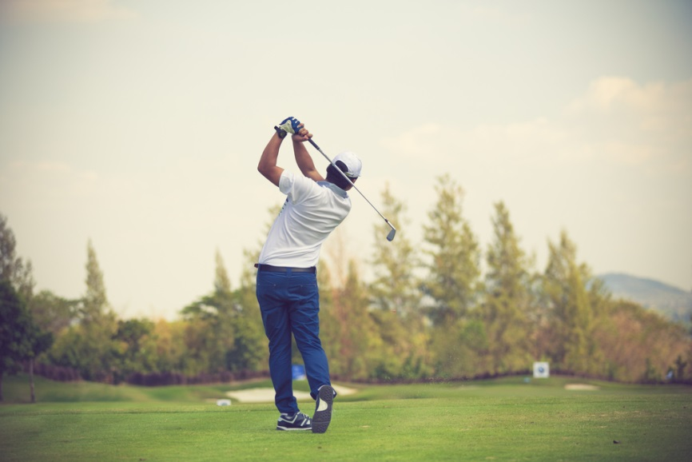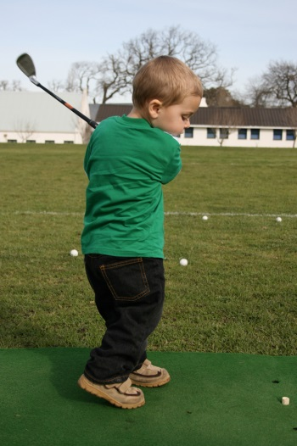

According to the Fitts and Posner model of skill learning, explain the three phases a golfer would move through as they progress from beginner level through to professional. In your response, identify the performance characteristics and type of feedback the learner would require in each phase to maximise their skill learning. Also identify the phase you would expect the golfer to spend the shortest amount of time in.

**Question 36 (10 marks)**

From the point of inhalation, describe the mechanics of breathing, including pressure change and flow of oxygen through the cardiorespiratory system to supply oxygen to the working muscle/s.

**Question 37 (10 marks)**

Swimmers may use different stances when on the starting blocks at the beginning of a race. Identify which swimmer (A or B) would have the greater stability and describe Newton’s Three Laws of Motion in relation to the swimmer in picture B.

**A B**

**End of paper**

**Additional Working Pages**

______